Number marking and (in)defininteness in kind terms
Dayal 2004

Unique, non-unique
Familiar, non-familiar

Kind with entities in many worlds-taxonimy, individuals in the reference world

Singular, plural, mass

Narrow scope, wide scope

Kind level-generic, individual level -episodic

- DINOSAUR kind, and sub-kinds, and individuals
[DINOSAURS [TYRANASAURUSREX bill bob ] [STEGGOSAURUS sally sara ] [PTERADACTYLE terry tom ] ]
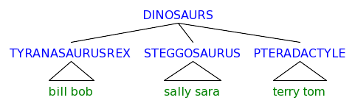
- The dinosaur paradigm
Context determines what level of the hierarchy will be relevant to the interpretation in a particular case.
a. *Dinosaur became extinct at various points in time.
b. The Dinosaur became extinct at various points in time.
(Kind = DINOSAUR, its spidered out to subkinds TYREX, STEGGO, PTERADACTYLE)
c. ?Dinosaurs became extinct at various points in time.
(Kind = DINOSAUR, its spidered out to bill, bob, sally, sara, terry, tom, but those are individuals so they cant become extinct)
d. The dinosaurs became extinct at various points in time.
(Individuals = subkinds of TREX which is spidered out to bill & bob, STEGGOSAURUS which is spidered out sally & sara)

 |  | singular |  | Plural |  | Mass
 |  | individual | Kind | individual | kind | individual | kind
 |  | is hitting his friend | extinct | is hitting his friend | extinct
Unique | Familiar | The dinosaur (in the corner)  <e> | The DINOSAUR  <s,e> | The dinosaurs (in the corner)  <e> | The DINOSAURS (STEGA,TREX)  <s,e> | The gold (in the corner)  <e>? | The golds (from north America)  <e>?
 | Non-Familiar | A pumpkin crusher (in the corner)  <e>? | A PUMPKIN CRUSHERS  <s,e> | Some pumpkin crushers  <e> | Some PUMPKIN CRUSHERS  (ones with hammers, ones with catapults)  <s,e>
Non Unique | Familiar | Nonunique, familiar, singular, individual | Nonunique, familiar, singular, kind | Nonunique, familiar, plural, individual
 | Non-Familiar | Any/sme dinosaur  <e> | Free choice Any DINOSAUR  <s,e> |  | Can any go with plural. Any ten tables is ok

Goal:
- There is a scale of definiteness, different languages choose different cut-off points for lexicalization of the definite determiner.
- Plural kind formation is the intensional counterpart (ie possible worlds) of the iota i operator of the definite determiner. Both are on a scale of definiteness.

Among the specific questions that this study bears on are the following:
- Are bare plurals, and by extension bare nominals in other languages, kind terms which yield indefinite interpretations in particular contexts, or are they systematically ambiguous between kinds and indefinites?
  - Kind → Indefinite
  - { Kind, Indefinite }
- Is there a grammatical difference between definite singular kind terms and bare plural kinds in languages like English?
- If such a difference exists, do definite plural kinds in languages like French and Italian belong with the English definite singular or with the bare plural?
- To what extent is it possible to predict whether kind terms in particular languages will be bare or definite and what range of readings will such nominals have?

Kind terms can be bare or have the definite determiner in some languages.
Kind terms can be singular or plural in some languages.

Many studies work on the parallels between bare plurals and indefinites, ignoring the kind/definiteness connection.

Claim: languages without determiners will show the Kind (Carlson/Chierchia) approach to be correct

- Typology of Relevant Info
 | Plural Morphology | Definite Determiners
English,  German  (Russian?) | Yes | Yes
Hindi | Yes | No
? | No | Yes
Chinese | No | No

- Patterns of kinds and determiners
 | Singular Kind | Plural Kind
Determiner | A,C | A, D, F
No determiner | B, D | B, C, F
Special Kind  Determiner | E | E
A: Romance languages
B: Hindi, Russian
C: English
D: Not Found
E: Not Found
F: German

2. Kind terms in languages without determiners

BEGIN Summary from intro
Null Hypothesis: bare nominals are ambiguous for (in)definiteness
Prediction: You can find them in both indefinite and definite contexts
Prediction: They will be either definite or indefinite in all contexts
This seems to be the prediction she is testing

With the predicate “be everywhere” its impossible to have a definite singular
- Bare singular nominal can’t be definite: Hindi (Dayal 2004.1a)
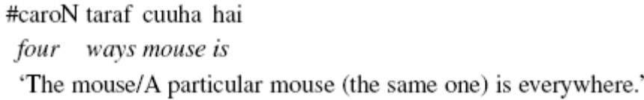
Available: #A particular mouse is everywhere.
Not Available: Everywhere you look, there’s a mouse.

- Bare plural nominal can be definite: Hindi (Dayal 2004.1b)
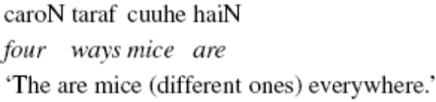

But this is also true in English
- The mouse is everywhere.
#‘The mouse/A particular mouse (the same one) is everywhere.’
Maybe it’s supposed to be compared to the mouse in object position in English (but its in subject position in the Hindi sentence)
- There is a mouse everywhere.
#There is a certain mouse everywhere.

Hypotheses B: bare nominals are ambiguous between definites and kind denoting terms.
: Number morphology constrains the cardinality of the kind
Hindi and Russian involve a subgroup interpretation

Plurals are ok because subgroups can take scope under the universal. Singulars are a singleton set so there is no meaningful subgroup available to be under the universal.

Languages where bare nominals are not ambiguous between kind and indefinites suggest something stronger than Hypothesis B, that kind → indefinite.
END discussion from intro

2.1. Some Background

Two approaches to generics (kind terms):
Kind Based: Carlson 1977, 1989, Chierchia 1998
English bare plurals refer to kinds
Ambiguity Based: Wilkinson 1991; Gerstner & Krifka 1993; Kratzer 1995; Diesing 1992
Bare plurals are ambiguous between kind terms and indefinites.

Carlson’s arguments that bare plurals are kinds:
  - There are predicates that only apply to kinds.
-Unshakeable
  - Variability in quantification can be predicted by the lexical and aspectual properties of the predicate.
-undermined by the parallel quantificational variability of indefinites (Lewis 1975; Kamp1981; Heim 1982), which can be accounted for in either approach
Kind Based: same mapping algorithm, different denotations
Ambiguity Based: bare plurals are the same as indefinites
  - There are systematic scope differences between bare plurals and indefinites.
-still a good case in favor of the Kind based approach

- Indefinites may take wide scope over the negation operator while bare plurals cannot.
a. Indefinite
John didn’t read a book
Narrow: It’s not case that there is any book which John read.
Wide: There is a certain book which John didn’t read.
b. Bare plural
John didn’t read books
Narrow: It’s not the case that there are any books which John read.
Wide: # There are some books which John didn’t read.
- Indefinites may take wide scope over intensional operators while bare plurals cannot.
a. Indefinite
John wants to meet a movie star
Narrow: John wants to meet someone who is a movie star.
Wide: There is a certain movie star who John wants to meet.
b. Bare plural
John wants to meet movie stars
Narrow: John wants to meet some movie stars.
Wide: # There are certain movie stars who John wants to meet.

Technology:

Chierchia 1998 approach to kinds
- Nominalization Operation (‘down’)
⋂ is a partial function (P) which returns the set of distinct individuals <e>, which are defined by the maximal individuals (via i) which have the property (<e,t>) satisfied in situation (s). Basically it takes a predicate <e,t> and nominalizes it to the <e> which have that property.
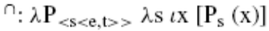
Chierchia’s proposal (1998:349)
-Uses the Fregean view, the individual counterparts of the properties associated with common nouns are kinds so “kinds can be regarded as the ‘nominalization’ of (predicative) common nouns and predicative common nouns as the ‘predicativization’ of kinds.
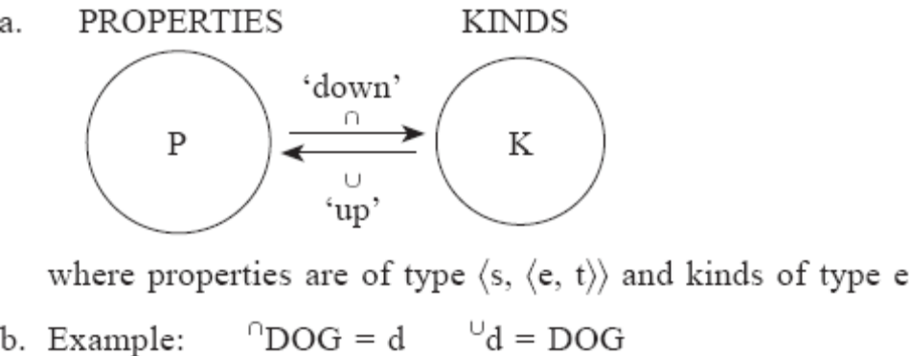

Go to make handout of Chierchia, made half of one, here is part. See also chierchia-1998-Reference to kinds across languages-notes.doc

Chierchia 1998: 3.2. Type Shifting as a ‘Last Resort’

Partee 1987:
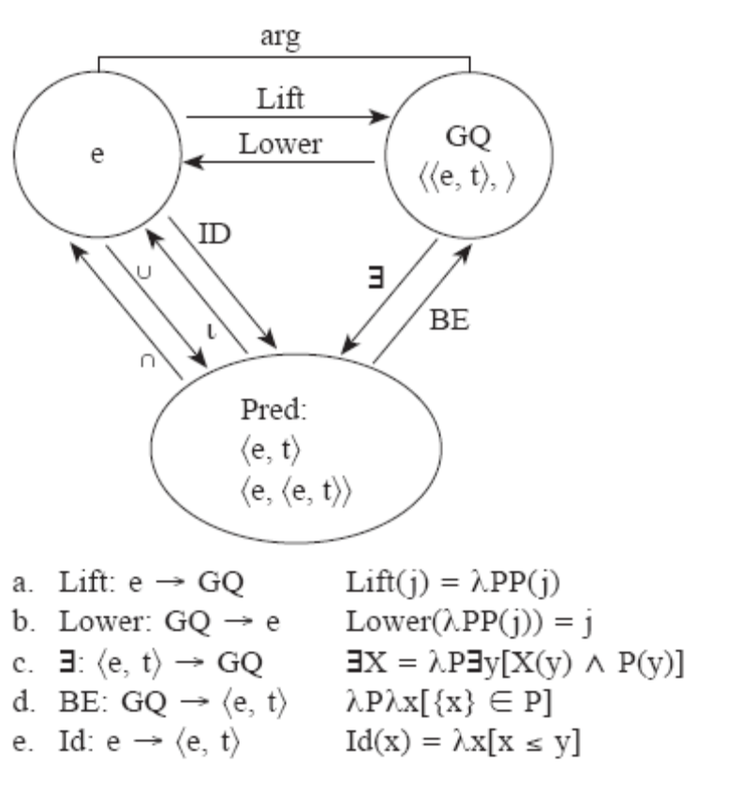
Lift: turns and individual <e> into a GQ<<e,t>,t> by taking all sets to which it belongs.
Existential closure ∃: turns a GQ <<e,t>,t> into a predicate <e,t>/<e,<e,t>>, traditionally the meaning of ‘a’
Montague’s BE: turns a predicate <e,t> into a GQ <<e,t>,> Partee argues that these operations are in the analysis of copular constructions.
⍳ : selects the greatest element from the extension of a predicate, typically the meaning of the definite article.
Id : the inverse of ⍳ is the ‘part of’ relation when the x is larger than 1.
Montague’s cap ⋀ cup ⋁ : switch back and forth between intensions and extensions, lambda abstraction over and application to the world variable.
⋀DOG = λw DOG_{w}
⋂ : combination of ⋀ and ⍳ restricted to kinds, turns entities in different worlds with a property <<e,t>,s> to individual kinds <e>, the intensionalized version of ⍳.

- Blocking Principle (Type Shifting as Last Resort)
Languages may encode different type shifting operations in determiners; if the operation is encoded in a determiner then it cannot apply covertly.
For any type shifting operation τ and any X:
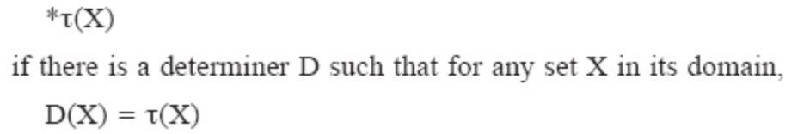

- Derivation for common noun in its kind use
(Using Montague world variable on all predicates (?), Semantics I, lecture 16)
Dayal follows Partee 1987 and Chierchia 1998: Common Noun phrase is <s,<e,t>>, the lexical determiners encode a type shifting operations which turns them into <e> (often as a determiner ‘the’ <<s,<e,t>>,<e>>) or into <<e,t>,t> (often as a quantifier ‘some/all’ <<s,<e,t>>,<<e,t>,t>>) (Dayal 2004:413)

[<e> [<<s,<e,t>>,<e>> down ] [nonsingular [<s,<e,t>> dodo ] -s ] ] 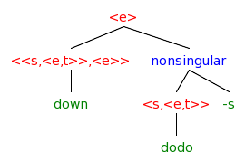

Lexical entries:
〚Dodo〛= λz_{<e>} . z is a Dodo
〚⋂〛 = λP _{<s,<e,t>> .} λs_{s} . ⍳x_{e} [P_{s} (x)]
Combine:
By FA
〚⋂Dodos〛=[⋂](〚Dodo〛)
= [λP _{<s,<e,t>>} λs . ix [P_{s} (x)]](〚Dodo〛)
= λs . ix [〚Dodo〛_{s} (x)]
= λs . ix [λz_{<e>} . z is a Dodo in s ](x)
= λs . ix: [x is a Dodo in s]
The kind Dodos are defined as the set of distinct maximal individuals x across worlds s that have the property Dodo.

- Dodos as defined above combines easily with a kind level predicate as its argument.
[VP [<e> [<<s,<e,t>>,<e>> down ] [nonsingular [<s,<e,t>> dodo ] -s ] ] [. (are) [<s,<e,t>> extinct ] ] ]
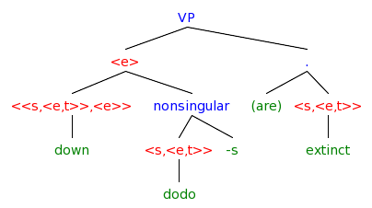
Chiercia 1998 2.3. Kinds

“Kinds are generally seen as regularities that occur in nature… but their spatiotemporal manifestations are typically ‘discontinuous’” “Artifacts like chairs can be kinds as long as we can attribute a sufficiently regular behavior to them. (Carlson 1977:26, Krifka 1995)
- Any natural kind (dog-kind) will have a corresponding property (being a dog).
- The correspondence between (natural) properties and kinds suggests that there must be [functions] to get from one to the other.
- Fregean view of predication: each property has an individual counterpart.
The individual counterpart of common nouns are kinds
The individual counterpart of verbs are action types

- Property <s,<e,t>>
〚DOG〛= λw . DOG_{w}
- Kind <e>
〚d〛= dog-kind
- Down ⋂ Nominalizes:
Returns the kind corresponding to the characteristic function/property
⋂DOG = d
- Up ∪ Predicativizes:
Returns the characteristic function/property
⋂d = DOG
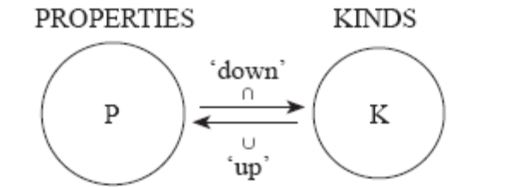
- The view of the domain of discourse above allows us to identify a kind as the totality of its instances which can be modeled as the set of dogs.
- This means we can model kinds as individual concepts of ‘functions from worlds into pluralities’ which identify classes of objects with regular behavior, they usually have a plurality of instances.
- A kind (like the dodo) may lack an instantiation in this world, then the kind function from worlds to pluralities is undefined.
- Ordinary individuals are a transworld line, which in every world picks out the manifestation of the individual.
- Does this mean a kind is a spidery individual across worlds of atoms which show a significantly regular behavior?

- The design of the domain
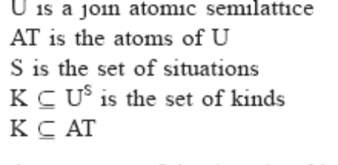
Unsorted types <e> as x, y
Sorted types <e??> as x_{σ}
Plain singular objects x_{o}
Pluralities x_{p}
Kinds x_{k}

Caveat: the set of equations in (14) is nontrivial, as the cardinality of U^{S} is larger than U, yet we require that kinds be a subset of U. To put it plainly, if K is too big a subset of U^{S} it might not fit into U.
Nonstandard set theories like Property Theory Chierchia 1984, Chierchia and Turner 1988 might work

- Up ∪ Predicativizes/ideal forming operator, gives a mass denotation?
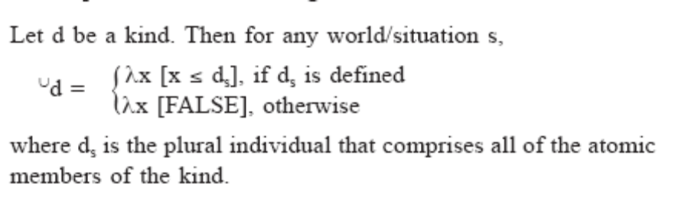
d is a kind, so for any world s, predicatize d returns whatever x if x is a subgroup of the kind d in that s, if the kind d in that s is defined, if its not defined then the predicativezation is null?

- The extension of the property corresponding to dog-kind is the ideal generated by the totality of dogs. Kind of like prototype theory. (Rosch)

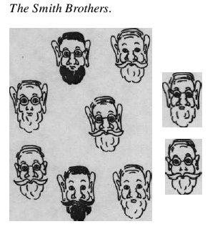
- A singular or a plural can be a good instance of a kind, meaning that the property corresponding to a kind comes out as being mass.

END Chierchia’s predicativizer discussion

- Derived Kind Predication (DKP) for kind readings in episodic contexts (Cheirchia31)
a. ∃x [⋃that kind of animal(x) ⋀ ruin my garden (x)]
b. ∃x [⋃that(x) ⋀ saw in the zoo (you, x)
c. Derived Kind Predication (DKP)
If P applies to objects and k denotes a kind then
P(k) = ∃x[⋃k(x) ⋀ P(x)]
Dogs bark, so if x is a member of the kind dog, and x barks, then the statement is true? But the statement seems to me to say that all dogs bark, not just the x that we chose. So it should say for all x which are dogs, and x barks is true.
- Derivation for common noun in its object use
Why do I have to take dog <et> down to a kind <e> and back up to a predicate <et>? Why cant I just use the original predicate of dog? Is this to eliminate animals with the dog property but aren’t part of the taxonomy of dog? Where is the sort mismatch is it from <s,<e,t>> to <e,t>?
Lexical entries:
〚Dog〛= λz _{<e>} . z is a Dog
〚⋂〛 = λP _{<s,<e,t>> .} λs_{s} . ⍳x_{e} [P_{s} (x)]
〚⋃〛 = λk _{<s,e> .} λs_{s} . λv_{e} [ v ≤ k_{s}]
〚barked〛= λy ∊ <e> . y barked
〚not〛= λQ_{<e,t>} .⇁Q
〚some〛= λF_{<e,t>} . λH_{<e,t>} . ∃a [ F(a) ⋀ H(a)]
Combine:
By FA
〚⋂Dogs〛 =[〚⋂〛]( 〚Dog〛)
=[ λP _{<s,<e,t>> .} λs_{s} . ⍳x_{e} [P_{s} (x)] ]( 〚Dog〛)
= λs . ⍳x_{e} [〚Dog〛_{s} (x)]
= λs . ⍳x_{e} [λz _{<e>} . z is a Dog in s (x)]
= λs . ⍳x [ x is a Dog in s]
〚⋃⋂Dogs〛 =[〚⋃〛]( 〚⋂Dogs〛)
=[ λk _{<s,e> .} λs_{s} . λv_{e} [ v ≤ k_{s}]]( 〚⋂Dogs〛)
=.λs_{s} . λv_{e} [ v ≤〚⋂Dogs〛_{s}]
= λs_{s} . λv_{e} [ v ≤ ⍳x: [ x is a Dog in s ] ]
〚some ⋃⋂Dogs〛 =[〚some〛]( 〚⋃⋂Dogs〛)
(the “some” part is intrudced by the DKP)
=[ λF_{<e,t>} . λH_{<e,t>} . ∃a [ F(a) ⋀ H(a)] ] ( 〚⋃⋂Dogs〛)
=[λH_{<e,t>} . ∃a [〚⋃⋂Dogs〛(a) ⋀ H(a)]
=[λH_{<e,t>} . ∃a [[λs_{s} . λv_{e} [ v ≤ ⍳x: [ x is a Dog in s ] ]](a) ⋀ H(a)]
=[λH_{<e,t>} . ∃a [λs_{s} . [ a ≤ ⍳x: [ x is a Dog in s ] ] ⋀ H(a)]
〚some ⋃⋂Dogs barked〛 =[〚some ⋃⋂Dogs〛]( 〚barked〛)
=[[λH_{<e,t>} . ∃a [λs_{s} . [ a ≤ ⍳x: [ x is a Dog in s ] ] ⋀ H(a)]]
( 〚barked〛)
=∃a [λs_{s} . [ a ≤ ⍳x: [ x is a Dog in s ] ] ⋀ 〚barked〛(a)]
=∃a [λs_{s} . [ a ≤ ⍳x: [ x is a Dog in s ] ] ⋀
[λy ∊ <e> . y barked ](a)]
= λs_{s} .∃a : [ a ≤ ⍳x: [ x is a Dog in s ] ⋀ a barked ]
〚not some ⋃⋂Dogs barked〛= 〚not〛(〚some ⋃⋂Dogs barked〛)
= [λQ_{<e,t>} .⇁Q] (〚some ⋃⋂Dogs barked〛)
= ⇁〚some ⋃⋂Dogs barked〛
= λs_{s} .⇁[ ∃a : [ a ≤ ⍳x: [ x is a Dog in s ] ⋀ a barked ] ]
No x exists such that x is of the set of distinct maximal individuals x across worlds s that have the property Dog and x barked.

[NegP<t> not [VP<t> [<<et>t> [DKP<<et>,<<et>t>> some ] [<et> up [<s,e> down [nonsingular [<s,<e,t>> dog ] -s ] ] ] ] [<et> barked ] ] ]
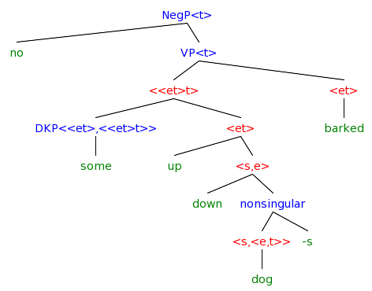

Diesing: bare plurals are ambiguous between kinds and non-quantificational/weak indefinites. Obligatory narrow scope below negation is derived by “eliminating text level existential closure” ???

So far both Carlson’s and Diesing’s approaches work well. In the cases above, the bare plural lacks one of the two readings that indefinites allows. But in an interaction with an adverbial the bare plural has an additional meaning that the indefinite doesn’t have.

- Bare plurals allow narrow scope with adverbials
Indefinites: GQ = <<e,t,t> must raise
# John killed a rabbit/some rabbits for an hour. ∃ > adv
Wide: There are some rabbits which John tried to kill for a time period lasting an hour.
Narrow: John tried to kill for an hour, what he tried to kill was some rabbits. (?)
Bare plurals: kind = <e> in situ
John killed rabbits for an hour. adv > ∃
Wide:
Narrow: John tried to kill for an hour, what he tried to kill was some members of the rabbit kind. (?)
Narrow Incorporated: John tried to do some rabbit killing for an hour.
Is there even an ∃ here? I don’t get how the readings work and what is excluded or the derivations behind them. How does she know the scope of the two readings?
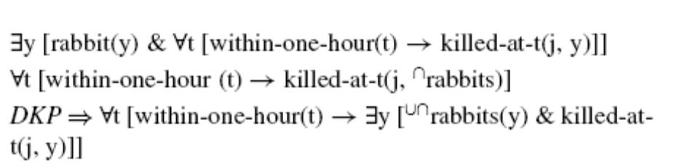
vs
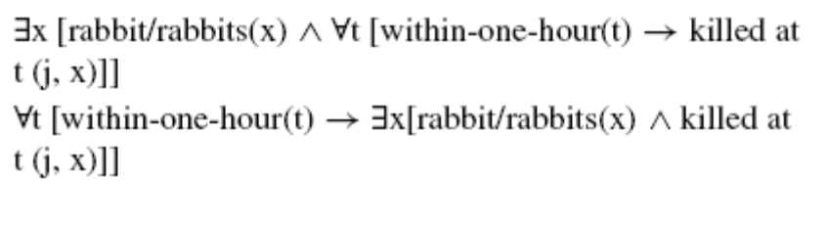
In the kinds-based approaches the indefinite and kind have different types so they should be able to take different scope positions. The indefinite (<<et>t>) cannot be the direct argument of ‘kill’ where as the kind (being of type <e>) can be the direct argument of ‘kill’ due to the DKP, ultimately yielding an existential with narrow scope. (See Zucchi and White 2001) for a different approach which relies on reference to kinds for bare plurals and mass terms)

What does the work here is the type difference. If you allow that kinds are in the grammar, and are of type <e> you can derive they extreme narrow scope, ie they don’t need to move.

But, being type <e> doesn’t that mean that you have no variable, but rather a unique reference and so there will be no existential closure youre already bound/closed in some sense.

Also, another way of getting extreme narrow scope, or no scope at all is by having a kind be “incorporated” ie a modifier of the verb as type <e,t> which merges with the verb through predicate modification. In this case again there is no variable that needs to be bound and thus no feeling of existential closure. Is that what this footnote is about: “There is a third approach to weak readings of bare plurals that one might consider, namely the semantic incorporation account of Van Geenhoven (1998). “bare nominals in direct object position … an incorporation analysis may be applicable” (Dayal 2004: 403) Her goal is “to isolate contexts in which interpretative differences hinge on number marking alone.”

2.2. A New Argument for Kinds

See section 2.2 for the Contrast plays a role in such cases

Hindi, Russian, Polish and Chinese bare nominals are compatible with both kind level predicates and definite object level readings when making a habitual statement about particular entities salient in the discourse.

- Predicates with kinds
X be extinct
X be common
X evolved from Y
X be protected by law
Someone invented X.

- Hindi singular and plural bare nominals used as kinds (D14)
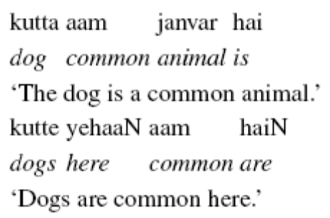
- Hindi bare (plurals) used as definite plurals (D17) (singulars behave differently see section 3)
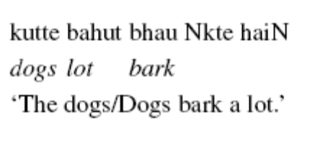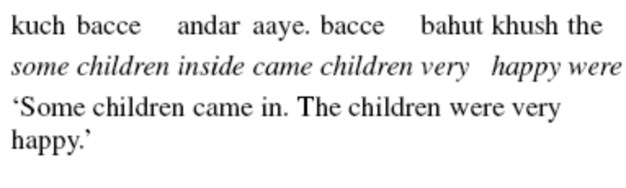
Bare nominals in Hindi (Verma 1966; Gambhir 1981), Russian (Cherchia 1998) and Chinese can also be indefinite.

- Hindi singular bare nominals used as indefinites (D19)
is
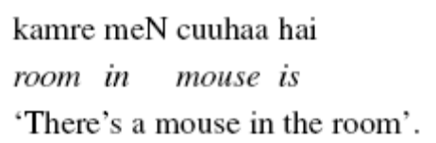
moving
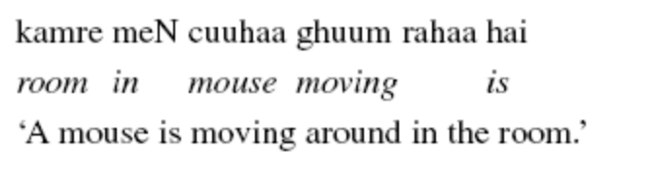
was singing
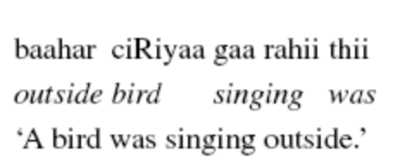

What is the difference between weak indefinite and indefinite reading?

- Hindi bare plurals need further probing, they only allow a narrow scope existential reading, not a wide scope existential reading. (a definite interpretation is possible with certain intonation patterns)
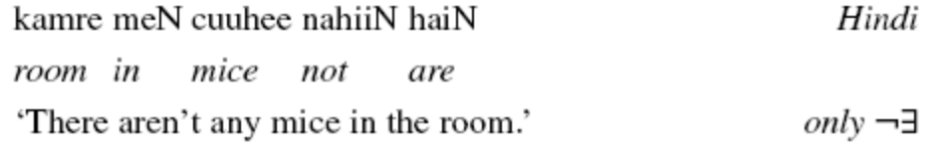

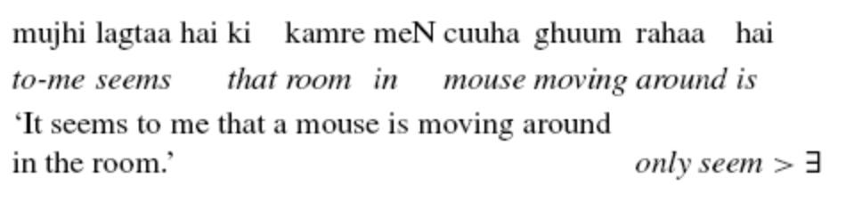
(In this example seem is in a different clause so ‘a mouse’ cant get scope over it. Isn’t it in a different clause in English too?)

The bare nominals in determinerless languages are consistent with both approaches to genericity.
In the kinds- based approach:
quantification over instances of the kind, DKP ensures obligatory narrow scope.
In the ambiguity approach:
non-quantificational/weak indefinites that must occur within the sentence level existential closure in non-generic sentences.

Hindi in some contexts bare singulars are not ok while bare plurals are fine:
-this is supposed to be different form English, but I don’t see how it is.
-caroN taraf doesn’t translate well, it is literally “in the four directions” or “on the four sides” it doesn’t have the universal quantifier ‘every’ sare or ‘each’ har’
-why were these predicates chosen, why are there conjoined predicates in the second sentence?
- Bare singular
A child was playing all over the place
A child was playing everywhere
The child was playing all over the place
The child was playing everywhere
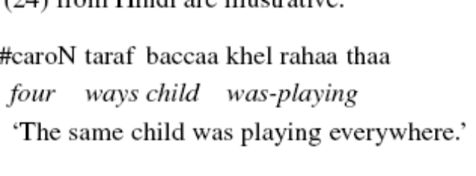
Incorrect: ∀x [place(x) →∃y [∪∩kid/kids(y) ∧ play-in-x(y)]]
Incorrect: ∀x [place(x) →∃y [kid/kids(y) ∧ play-in-x(y)]]
Correct: ∃y [kid/kids(y) ∧ ∀x [place(x) →play-in-x(y)]]
Solution by Dayal28b
Even a narrow scope existential cannot yield a plausible reading since the instantiation set of the kind in the given situation is a singleton.

- Bare plural
Some children was playing all over the place
Some children were playing all over the place
The children were playing all over the place.
The children were playing everywhere.
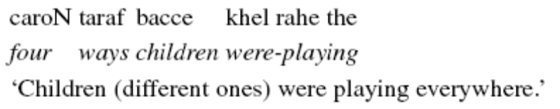
Correct: ∀x [place(x) →∃y [∪∩kid/kids(y) ∧ play-in-x(y)]]
Correct: ∀x [place(x) →∃y [kid/kids(y) ∧ play-in-x(y)]]
Incorrect: ∃y [kid/kids(y) ∧ ∀x [place(x) →play-in-x(y)]]

- Bare singular
A child was playing in the room and a child was sleeping.
A child was playing and a child was sleeping in the room.
The child was playing in the room and the child was sleeping.
The child was playing and the child was sleeping in the room.
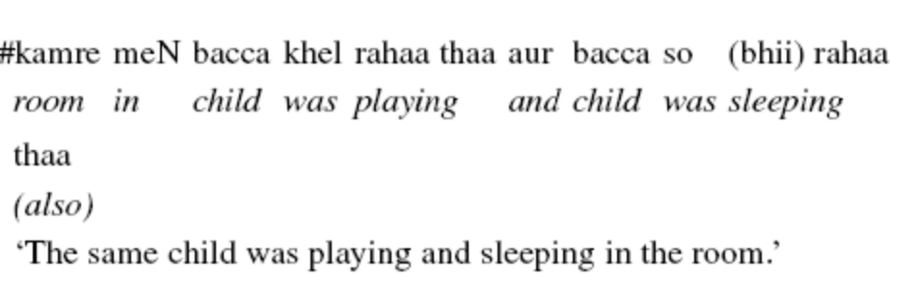
- Bare plural
Some children were playing in the room and some children were sleeping.
Some children were playing and some children were sleeping in the room.
The children were playing in the room and the children were sleeping.
The children were playing and the children were sleeping in the room.
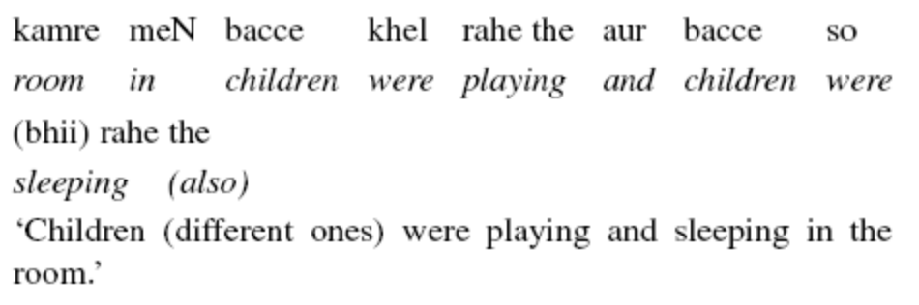
Dayal suggests a modification which would fit into the kinds approach, but not into the ambiguity approach.

- Number marking constrains the size of the instantiation set
-although kinds are conceptually plural, we can constrain the number of their instantiations in a given situation
-since object level predicates apply to instantiations of kinds, then we can constrain the number of instantiations in a given situation
a. For all situations s such that ⋃K_{s} ≠ ⊘, |⋃K_{s}| = 1 if K is a singular term and |⋃K_{s}| ≥ 1 if K is a plural term
In prose: for all situations s where the set of entities with the Dog property is not null, the absolute value of that set is 1 if the kind is a singular term, and its greater than 1 if k is a plural term. So there is one member of the dog kind present, or there is more than one member of the dog kind present.
b. ∀x [place(x) → y [⋃⋂kid_{s}(y)/⋃⋂kids_{s}(y) ⋀ play-in-x(y)]]
In prose: For all x such that if x is a place then y is a kid or kids and y plays in x

In the ambiguity approach we can’t constrain the number of instantiations of a kind, since there is no kind. On the other hand in the ambiguity approach these are (variables?) In order to argue against the ambiguity approach I need to know what their analysis is of
A. bare plurals in these contexts, and
Dayal says for the ambiguity approach bare plurals have the same denotation as singular indefinites
B. what they think of plural morphology.

The result of D28 is that bare singulars have singleton member of the kind, so a singleton can’t be everywhere, and the bare plurals have different subgroups so they can be everywhere.

- Another option:
Number morphology gives a implicature, so they differ in their access to their instantiation sets.
Plural kinds allow access to the objects in their extension
Singular kinds are (themselves) atomic entities that don’t allow access to the objects in their extension
In this approach bare singulars in non-kind level contexts cant be derived with kind formation. So we can use ⍳
The ⍳ way for the singular: ∀x [place(x)→play-in-x(ιy[kids (y)/kidss(y)]]
In prose: For all x such that if x is a place then play in x, the unique y who is a kid or kids did.
The kind way for the plural: ∀x [place(x) →∃y [∪∩kidss(y) ∧ play-in-x(y)]]
In prose: For all x such that if x is a place then there is y, y are members of the kid instantiation set in s and y play in x

To better understand the iota and the familiarity presuppositions, let’s look at contexts where we get the indefinite judgment for bare singulars, this is where the entity isn’t salient or firmly established in the common ground.

- Bare singular with indefinite reading (D19a)
“There’s a mouse in the room” I can see its droppings, or I can hear it squeak, or I just caught a glimpse of it.
Crucially: uniqueness is not violated, although familiarity is not satisfied.

- Bare singulars
Denote a unique individual per situation s,
This does not entail that the entity be familiar

Section 3 will illuminate the choice between the two approaches to bare singulars.

2.3. More on Uniqueness and (Non)-Familiarity

Bare nominals cannot introduce discourse referents.

- Bare noun cannot pick out a novel entity from a previously introduced set. (uncontroversial judgments)
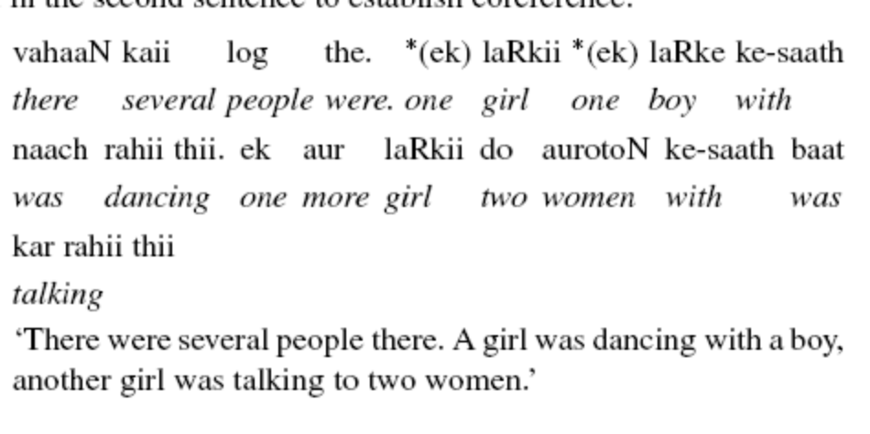
- Bare nominal can’t be used in a presentational context (judgments vary)
-I think the repetition of aurat is weird, otherwise without ek is ok…
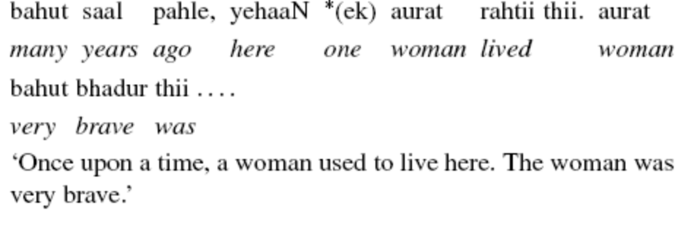
- Bare nominal can’t serve as an antecedent for pronominal discourse anaphora
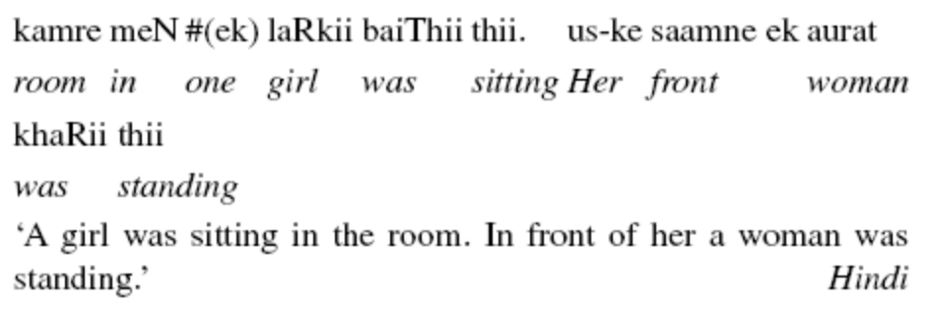

Judgments are affected by potentially different expectations people can have about the relevance of the entity referred to in the discourse.

Judgements about (in)definiteness are made along two dimensions, (non)-familiarity and (non)-uniqueness.

- Bare nominal can’t be used in a context with more than one potential referent
-ok if the bare nominal has intonational stress, focus induces an existential presupposition which the bare nominal predicates something about the presupposed entity. It’s a WOMAN who is bringing the mail
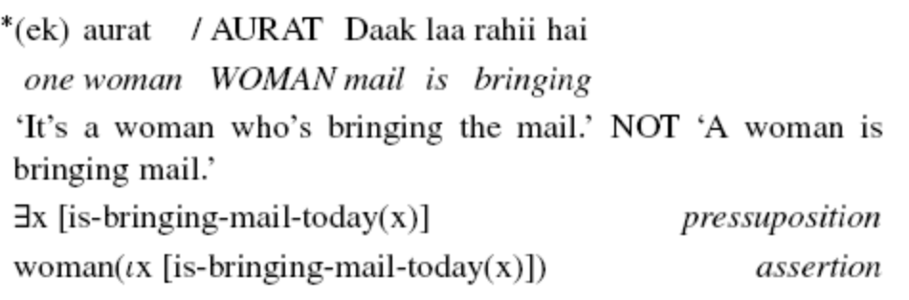
- The bare nominal has a situation variable, set at the sentential level and can only be manipulated by locative and temporal phrases that can function as topics
-if the nominal in two conjuncts are in different temporal or location parameter then the nominal can be repeated.
-c shows that the quantification by the locative doesn’t bind the situation variable on the bare nominal.
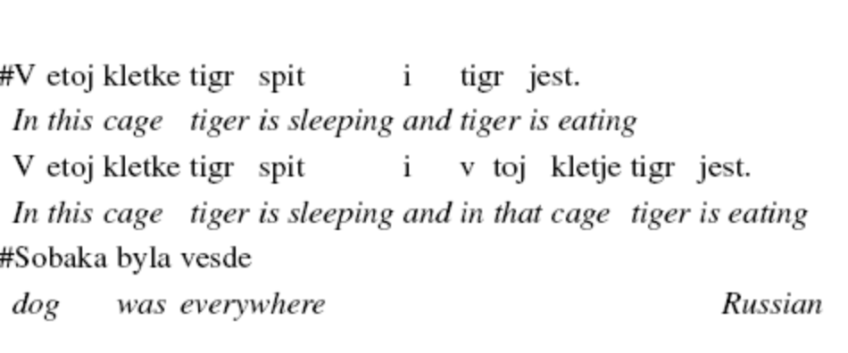
Hindi a) can have two “cat” so there should be two situation variables (it seems obvious there are two sentences there)
b) cant have two “cat” so there should be one situation variable (it seems obvious, there is only one sentence there)
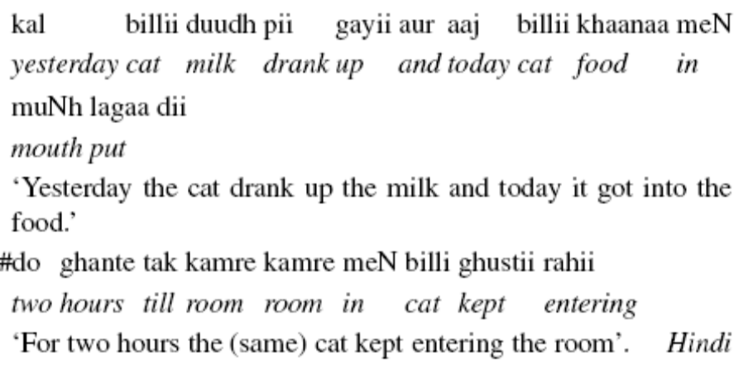
Crucially, existential quantification associated with bare nominals is always local.

Due to the restriction on singular kind terms a difference in interpretation is predicted whenever there is DKP-induced existential closure inside a quantificational structure within a situation.

In this section Dayal has fact that Hindi and Russian bare singulars are used in X while bare plurals in Y to argue that there is a number restriction on the instantiation set of kind terms.

- Languages without number morphology like Chinese, Japanese, Korean should be like bare plurals and show no constraints on the size accessibility of their instantiation sets.
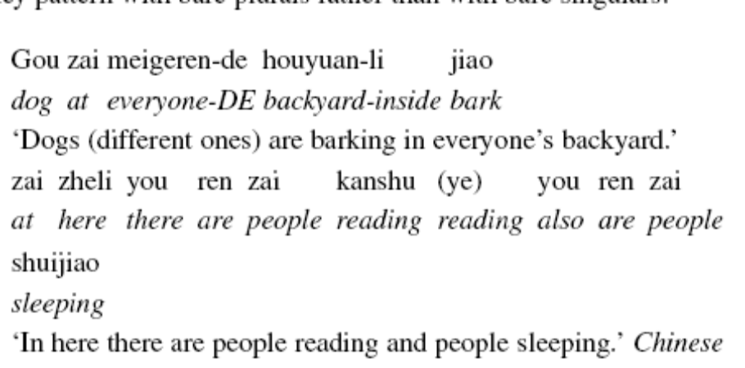

2.4. Syntactic Restrictions and Null Determiners

So far Dayal has argued that bare nominals in languages without determiners are only ambiguous between kinds and definites (uniqueness but familiarity is seperate).

Apparent indefinite readings come from the DKP which introduces existential quantification at the NP. The DKP (or the indef reading?) has morphologically triggered number restrictions.

Section 2.4 will use Z to argue that bare nominals are not bon fide indefinites.

- The Semantics (Partee 1987, Chierchia 1998)
a. NP (<e,t>) + Dº (⋂,⍳,∃) ⇒ DP (<e> or <<e,t>t>)
b. ⍳ : λP ⍳x [P_{S} (x)] <<e,t>,<e>>
c. ⋂ : λP λs ⍳x [P_{S} (x)] <<e,t>,<s,e>>
d. ∃ : λP λQ ∃x [P_{S} (x) ⋀ Q_{S} (x)] <<e,t>,<<e,t>t>>

- The syntax of bare plurals
- Null determiner (Longobardi 1994, 1999)
- Bare NP for languages with no determiner (Carlson 1977, Chierchia 1998)
- All arguments are DPs, N moves to D (Longobardi 1994, 1999 for Romance, Li 1997 for Chinese)
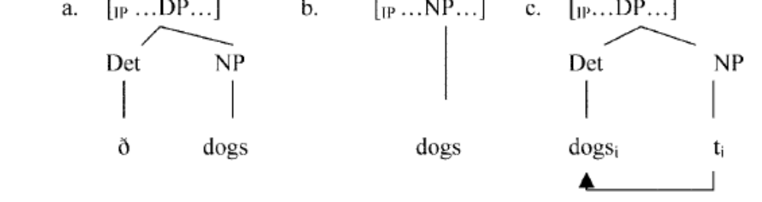

In object position bare singulars could be incorporated (and receive existential interpretation), so Dayal has been using bare nominals in subject position only. But these have been subject position of unergatives and identity functions no? Have they been in the subject position of transitives?

Under (a) Hindi and Russian would have a null ∃ determiner in bare singulars. This would effectively restrict bare singulars to object position because Y.

Under (c) Hindi and Russian would allow bare singulars in all syntactic positions. This would account for why bare singulars have definite readings in all positions (type <e>) but have indefinite readings only in object position because X.

- Problems with (c):
Have to do ordering restrictions between interpretation and raising to block the indefinite reading.
Yet Chinese bare nominals in subject position lend themselves to generic interpretations, so there is a variable available for generic binding after N→D raising. If there is a variable, why wouldn’t it be available for ∃ binding in episodic sentences too. Bare plurals get the indefinite reading in subject position.

- Problems with (a):
Null determiners in subject position are possible with heavy bare plurals or conjunction in Italian. This doesn’t work for Hindi or Russian.
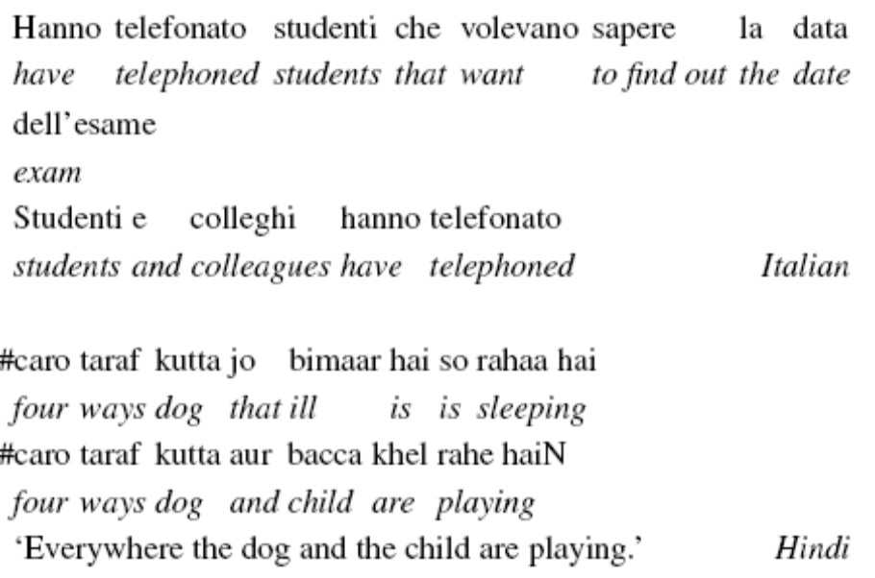
To look at the restriction of bare nominals to kind, generic and definite readings, but not indefinite readings (is that’s all that’s not allowed?) in determiner-less languages we must look at the Type shifting Blocking Principle in the next section.

2.5. Blocking and Ranking Effects in Type-Shifts

I put in stuff from Chierchia about the types and type-shift blocking earlier in the paper. I will copy Dayal’s things here.

- Two kinds of restrictions on type shifting:
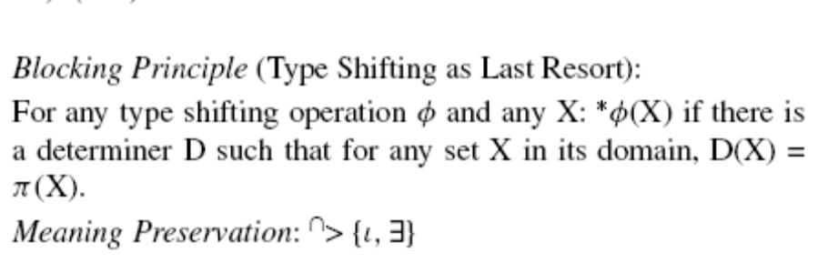
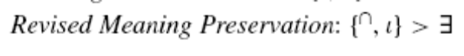(D39b)
Meaning preservation is a ranking of the type shifting operations in the order preferred to apply first when there is no overt determiner. I couldn’t find any mention of meaning preservation in Chierchia 1998.

- The difference between English and Hindi:
English bare plurals can use ⋂ but not ⍳ because there is already a determiner for ⍳.
There is no lexical definite determiner in Hindi, so ⍳ and ⋂ are available for bare nominals.
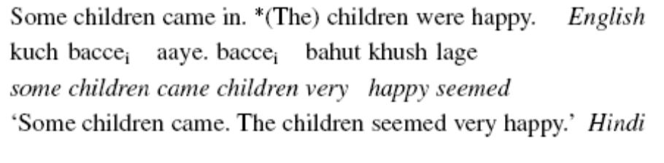

In later sections Dayal will present data that need a different approach to the blocking effects.

Hindi, Russian, Chinese have demonstratives and the unstressed ‘one’ in many places where English would use the or a.

- Criteria for identifying definite determiners, Consistency: Loebner 1985
Definite determiners have a contradictory reading when a predicate and its opposite are applied to the NP, demonstratives don’t. (contradictory because they assume there is a unique boy in the discourse, whereas demonstratives point to boys in different locations)
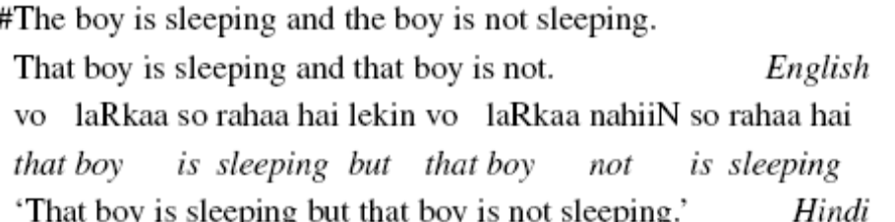

- Criteria for identifying indefinite determiners, Genericity: Kratzer 1998, Chierchia 1998
Indefinite determiners can have a generic reading, but ‘one’ can’t. (Does this show that ‘ek’ is ‘one’ or that ‘ek’ doesn’t encode genericity? Is this a solid test, it doesn’t feel as solid as the other one.)
A dog barks.
If it’s a dog it will bark. √ Generic reading
There’s a dog barking. √ Episodic reading
One dog barks.
If it’s a dog it will bark. # Generic reading
There’s a dog barking. √ Episodic reading
Kutta bhaunktaa hai
dog bark-Imperf is
If it’s a dog it will bark. √ Generic reading
There’s a dog barking. # Episodic reading
Ek kutta bhaunktaa hai
one dog bark-Imperf is
If it’s a dog it will bark. # Generic reading
There’s a dog barking. √ Episodic reading

- Also, unstressed numeral can’t give normal narrow scope interpretations.
No, a mouse isn’t in the room
It’s not the case that there’s any mouse in the room √ narrow
There’s a particular mouse who isn’t in the room √wide
No, one mouse isn’t in the room
It’s not the case that there’s any mouse in the room # narrow
There’s a particular mouse who isn’t in the room √wide
nahiiN, kamre meN ek cuuhaa nahii hai
no, room in one mouse not is
It’s not the case that there’s any mouse in the room # narrow
There’s a particular mouse who isn’t in the room √wide
Q: Is there a mouse in the room?
nahiiN, kamre meN ek cuuhaa (bhii) nahii hai
even
‘No, there’s not even one mouse in the room.’ √ narrow scalar

Dayal agrees (so does an anonymous reviewer and Krifka, I’m in good company ;) that if ‘ek’ was an indefinite determiner then it would explain what we have been looking at. If Hindi and Russian had the indefinite determiner, and not a definite determiner then all would fall out from the blocking theory. I don’t think these tests are very strong, it would be worthwhile looking further into ‘ek’. While learning Hindi/Urdu I felt the ek wasn’t the same as English one at all. For one thing its used a lot more…See Dayal’s footnote20
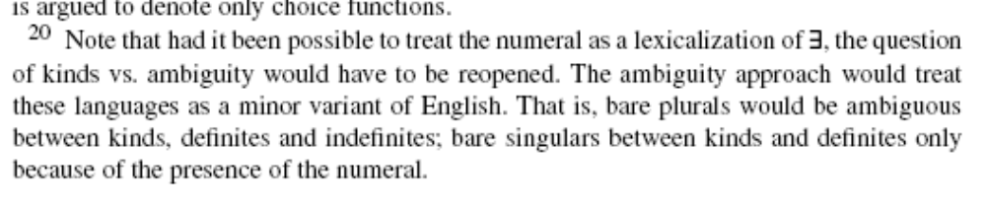

- Dayal reformulates the Meaning Preservation so that either kind formation or a null unique operator can be tried first {⋂,⍳}, then existential closure ∃ can apply.
- Kind formation ⋂ and uniquness ⍳ are simpler than ∃ because they changed the type without introducing quantificational force, so ⋂,⍳ are ranked over > ∃.

- Kind reference in Hindi Russian and Chinese doesn’t block the definite/unique reading, both are readily available.

Thus nominals should shift via ⋂ or ⍳ but not by ∃ .

In the English cases below a null unique operator ⍳ is blocked since we have an overt ‘the’ for it, kind formation is possible but it doesn’t apply because of the definite NP embedded inside the bare plural, widespread is a generic predicate rather than an episodic predicate, so it has no existential closure so the sentence is ungrammatical, see is episodic so existential closure ∃ is ok.

- The bare plural ‘parts’ cant be a kind in English or Hindi
The definite (this machine) inside a bare plural NP (parts of this machine) forces the extension of the bare plural NP to be constant across worlds, which doesn’t make sense.
a. *Parts of this machine are widespread.
The definite plural NP (the parts of this machine) refer to the kinds that make up the machine across worlds, so this does make sense. (?) Now I found a definite plural kind in English, just like Romance eh? (its even better with in than of, does this matter?)
b. The parts of/in this machine are widespread.
Hindi:
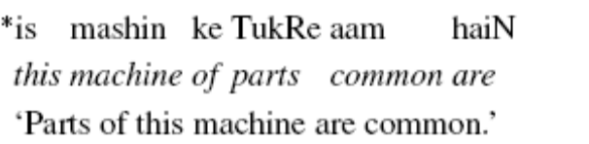
- The bare plural ‘parts’ isn’t a kind, it’s an indefinite.
Kinds don’t interact with negation, indefinites do
John didn’t see parts of this machine.
a. There are parts of this machine which John didn’t see. √ ∃⇁
b. Its not the case that there are any parts of this machine which John saw,
he saw parts of another machine. √⇁∃
John didn’t see the parts of this machine.
a. There are parts of this machine which John didn’t see. # ∃⇁
b. Its not the case that there are any parts of this machine which John saw,
he saw parts of an other machine. √⇁∃
Hindi
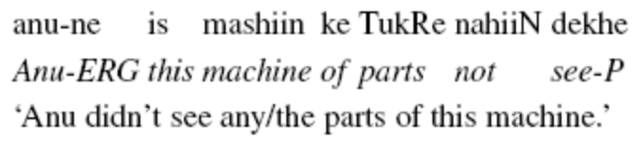
a. There are parts of this machine which Anu didn’t see. #∃⇁
b. Its not the case that there are any parts of this machine which Anu saw,
she saw parts of another machine. √⇁∃

Preliminary Conclusion: Hind bare plural parts is scopally frozen due to DKP, so it must have undergone ⋂.

So, what we (Dayal, and her confusing writing) took to be the frozen existential reading is in fact the (non-familiar) definite reading of a sentence with negation.

Final Conclusion: In Hindi ⍳ is freely available, so even in the absence of ⋂ (because of the definiteness of the embedded this machine) the ⍳ will block the ∃. So the Hindi sentence above really has “the parts” just as I felt it did ☺

In this section Dayal has shown bare nominals cant be simply classified as indefinites in languages without determiners, in fact they often show uniqueness but no care about familiarity.

Dayal showed the parallel behavior of bare plurals and bare singulars in Y contexts, and nonparallels in Z contexts.

Dayal introduced (new) data with a bare plural in English that actually wasn’t a kind (?)

Two ways of approaching the singular vs plural distinction were proposed but not explored:
either that the singular number morphology restricts the kinds instantiation set to singltons, or
operations are not permitted on instantiation sets altogether.

3. Singular Definite Kind Terms

Section 3 summary from the intro:
- There is no special semantics in the determiner with the English singulars
- The common noun that has two possible denotations.
- Object domain
- Taxonomic domain
- Singular kinds are instantiations of this
- Singular morphology is incompatible with kind formation
- Common nouns are grammatically atomic but conceptually plural

“Taxonomy is the practice and science of classification.” “within "Knowledge Management", taxonomies are seen as slightly less broad than ontologies.” “At the top of this structure is a single classification, the root node, that applies to all objects.” “an ontology is a data model that represents a set of concepts within a domain and the relationships between those concepts. It is used to reason about the objects within that domain.” wikipedia

The determiner ‘the’ and ‘a’ both have a uniqueness component, ‘the’ has a familiarity presupposition, ‘a’ has a non-familiarity/novel presupposition.
- Krifka et al. 1995: NPs with indefinite determiners are incompatible with a true kind interpretation.
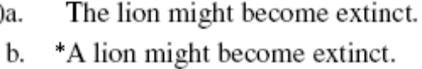
- Guerts 2001: NPs with indefinite determiners are compatible with a kind interpretation if it names a novel kind.
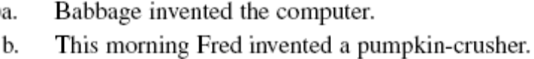

The appearance of the determiner is not special, ‘the’ for something known, ‘a’ for something novel to the discourse. The difference is that the discourse encompasses all knowledge of taxonomies?

So it appears that it is the common noun which has two denotations, one in the object domain, one in the kind/taxonomic domain. Presumably mass nouns have both denotations, yet when used as a kind they don’t allow a determiner.

However:
- Mass terms can’t have a definite determiner, even if they denote familiar kinds.
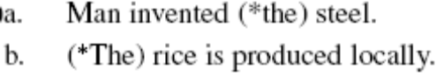

Maybe there is an incompatibility between singular morphology and kind formation.

Nouns have two ways of expressing kinds, either with plural morphology (which is unavailable for mass nouns since they are already lacking singletons if we take Swartzchild?s definition) or with a definite determiner (which is not possible for mass nouns, but why?) This argument doesn’t seem complete, maybe section 3 will be more explicit…

3.1. The Problem of the Singular Generic Determiner
⋂ and ⍳ differ only in intentionality.

⋂ is a function whose extension varies from situation to situation, while ⍳ is a constant function to a contextually anchored entity.

No language has a dedicated generic determiner (this is what ⋂ is??)

- However this view makes predictions that are not borne out.
Expect a language might lexicalize neither or both ⋂, ⍳
Neither: Hindi, Russian, Chinese
Both: Romance
Only ⍳: English (the = ⍳singular & plural objects, not mass objects and the =⋂ singular kinds but not plural kinds, not mass objects) For Dayal mass nouns are morphologically neutral (not singular as would be thought by verb agreement)
Only ⋂: None?

- The English paradigm
a. *(The) dinosaur is extinct.
b. Babbage invented *(the) computer.
c. (*The) Dinosaurs are extinct.
d. Babbage invented (*the) computers.
e. (*The) water is becoming scarce.
f. (*The) gold is rare.
g. Mr. X discovered (*the) gold.

There are two approaches to singular kinds.

Gerstner-Link 1988 and Krifka 1995 consider singular kinds like ‘the rat’ to be similar to some proper names like ‘The Sahara.’

- Krifka 1995: The definite determiner is an identity function which renders it essentially vacuous.
Singular Kinds | Certain Proper Names
The dinosaur | The Sahara
[<s,e> [Identity the ] [<s,e> down [singular [<s,<e,t>> dog ] -0 ] ] ] | [<s,e> [Identity the ] [singular [<e> Sahara ] -0 ] ]

However, this approach predicts that the definite determiner can combine with kinds like “water” or “dinosaurs” as its denotation is the identity function.

Ojeda 1991, Chierchia 1998, Dayal 1992, 1999 keep the basic denotation of the definite determiner (namely uniqueness ⍳ but override the uniquness requirements imposed by singular morphology. However, if the mass noun is number neutral as Dayal takes it to be, then the determiner should be able to apply to mass kind terms.

- Gerstner-Link 1988, Krifka 1995: The definite generic
‘The dinosaur’ is like ‘the Sahara’
The definite determiner is an identity function.
Bare mass terms: NP → N (DP → NP)
Then “the water” should be available
Have to force “the” in the “water” to be ⍳, not identity.

- Ojeda 1991, Chierchia 1998, Dayal 1992, 1999: The definite generic
Special operations override the uniqueness requirements imposed by the singularity morphology on the common noun. (is this needed if plural is absence of singltons and the singular is actually unmarked?)
Unclear why ⍳ shouldn’t apply to plural kinds or mass as well.

Section 3.2 proposes that the definite singular kind is formed by combining the normal meaning of the definite determiner with a taxonomic common noun (this is approach 2 far above?)

Taxonomic is in capital letters, bare plural kinds are in lower case letters.

Section 3.3 shows that singular definite generics don’t allow free access to instantiations of the kind.

Section 3.4 shows X about the crosslinguistic differential marking of definiteness on singulars but not on plurals.

- Krifka 1995: quantification over sub-kinds
kind level (extinct) and individual level (majestic, roars) predicates.
All can be objects or kinds, but the predicate type makes one or the other reading more salient.
a. Every/a/one/this (kind of) lion is extinct/majestic.
b. Two/three/most/those (kinds of) lions are extinct/majestic.
c. Every/a/one/this (kind of) lion roars (when it’s hungry).
d. Two/three/most/those (kinds of) lions roar (when they’re hungry).
e. The (*kinds of) dinosaurs became extinct at various points in time.

- Domain of sub quantification uses the taxonomic hierarchy:
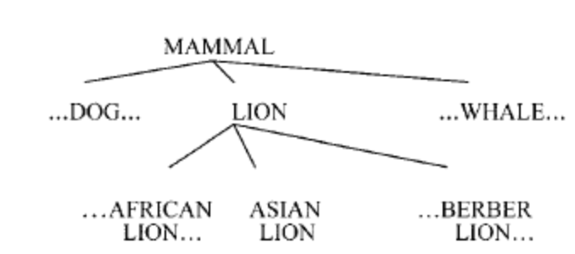

- Two ways to get the taxonomic interpretation
1. Common nouns denote ordinary individuals or properties of sub-kinds, standard determiners combine to yield the taxonomic reading
2. Determiners are ambiguous between normal determiners and functions mapping properties of individuals to the taxonomic domain and returning normal stuff. (what?)

Dayal adopts the first approach where nouns have two denotations and combine with determiners producing the taxonomic reading.

All that matters is that a taxonomic domain is relevant for English NP interpretation.

Every natural language determiner can combine with properties of kinds (she means something of type <e,t> I assume).

- DINOSAUR kind, and sub-kinds, and individuals
[DINOSAURS [TYRANASAURUSREX bill bob ] [STEGGOSAURUS sally sara ] [PTERADACTYLE terry tom ] ]
- The dinosaur paradigm
Context determines what level of the hierarchy will be relevant to the interpretation in a particular case.
a. *Dinosaur became extinct at various points in time.
b. The Dinosaur became extinct at various points in time.
(Kind = DINOSAUR, its spidered out to subkinds TYREX, STEGGO, PTERADACTYLE)
c. ?Dinosaurs became extinct at various points in time.
(Kind = DINOSAUR, its spidered out to bill, bob, sally, sara, terry, tom, but those are individuals so they cant become extinct)
d. The dinosaurs became extinct at various points in time.
(Individuals = subkinds of TREX which is spidered out to bill & bob, STEGGOSAURUS which is spidered out sally & sara)

- Definite generics don’t have to refer to well-established kinds, just familiar to the discourse. (Dayal 1992)
The factory produces two kinds of bottles, a green one for medicinal purposes and a clear one for cosmetics. The green bottle has a long neck. The clear bottle . . .
Need a contrast set

Stopped on page 33 of 58.

3.2. The Singular Definite Generic and Taxonomic NPs
3.3. The Singular Definite Generic and its Instantiations

Object level Context = Episodic Statement
Definite singular generic = Singular kind

- The singular kind is like a collective group noun (these are episodic statements)
Collective: The team is playing right now
Individuated: The team members are playing right now.
Bare plural: Rats reached Australia in 1770.
Singular kind: The rat reached Australia in 1770.

- Bare plurals have a transparent relation (distributive predication) to their instantiations. Singular kinds do not.
Context: at a zoo introducing animal species.
Those are lions and these are lions too.
That is the lion, and this is the lion too.

Don’t use:
- Subtle differences between plural kinds and singular kinds:
Generic statement
Dogs bark when they are hungry
The dog barks when it is hungry.
Generic statement, but can’t predicate being born of an entity (why not) Greenberg 1998 and Cohen 1998 apparently have arguments for why.
Rutgers Professors seem to be born on a weekday
# The Rutgers Professor seems to be born on a weekday.
Habitual/Generic followed by episodic referring to a member of the instantiation set. The quantification expresses an accidental rather than essential fact.
Yesterday between 3 and 4, whenever thieves entered the house, the police caught them.
# Yesterday between 3 and 4, whenever the thief entered the house, the police caught him.

d

3.4. Back to Definiteness Marking
The definite determiner in singular kinds is the normal definite determiner.
It picks the unique maximal entity out of a set, the set of ordinary individuals in the standard case, a set of taxonomic entities in the generic case (a kind collective in the kind case).

- Mass terms have taxonomic hierarchies just like lion, but they cant have the definite determiner even though they both have uniqueness and familiarity
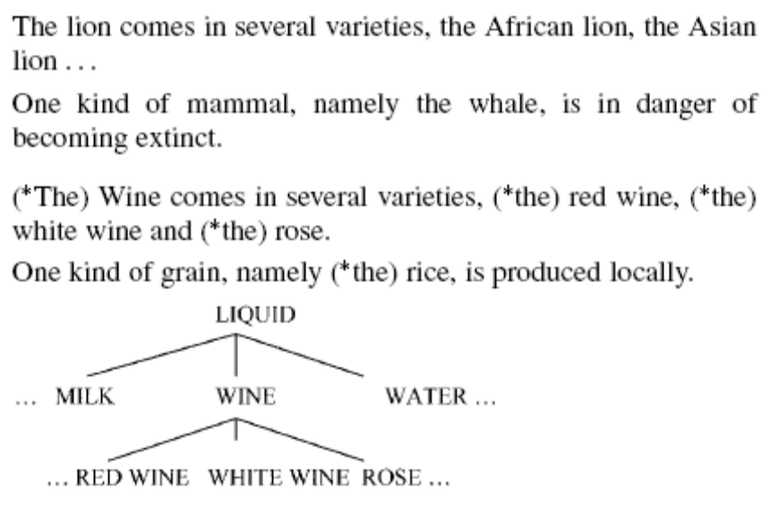
Singularity presuppositions from the number morphology force a type shifter ‘the’ to appear, since its ⍳ meaning is unavailable, its ⋂ meaning is used and it turns the singular or mass term into a kind. (Dayal 2004:435)

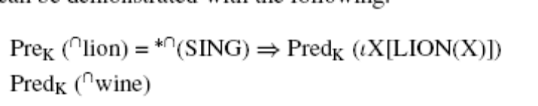

- Back to singular kinds in determiner-less languages. The overt ‘the’ in English introduces familiarity presuppositions, since Hindi, Russian don’t have an over ‘the’ their singular kinds should force no familiarity presuppositions.
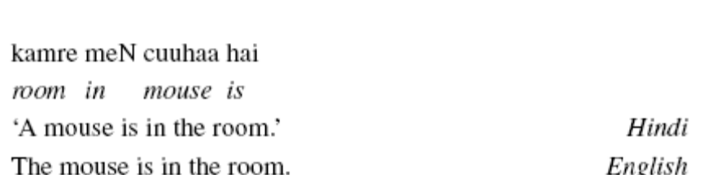

4. The Limits of Cross-Linguistic Variation

Summary from the intro:
Section 4: patterns of definiteness marking in plural kind terms.

Plural kind formation is the intensional counterpart (ie possible worlds) of the iota i operator of the definite determiner. Both are on a scale of definiteness.

Optionality between definite and unmarked plural kinds in German is derived by overt vs covert type shifting.

Hebrew definiteness optionality is different the German.

Interpretation of bare singulars is still not fully understood.

4.1. A Typology of Definiteness Marking

- Now paying attention to other language types:
Romance marks both singular and plural kinds as definite.
German allows both definite plural and bare plural as a kind.
Is German a problem for the Blocking Principle?
Languages with definite singular and bare singular as kinds.

- The system (Dayal 2004:437)
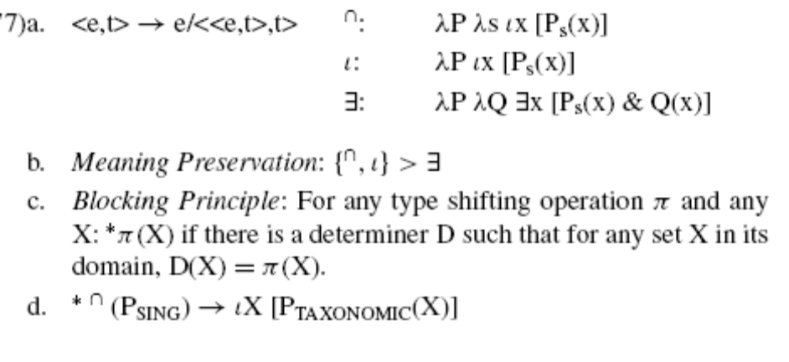
Point 1:
The kind former, ⋂ doesn’t have to be crosslinguistically covert, instead it can be in the same lexical item that encodes ⍳ (since they have the same function <<e,t>,e>, differing only in intentionality).

Point 2:
The two are on a definiteness scale, ⍳ is higher than ⋂. Some languages choose to encode the whole scale with a lexical item (Romance?) Other languages encode ⍳ with a lexical item but not ⋂ (which?). Other languages encode ⍳ with one item and ⋂ with another item (which). No language is found which encodes ⋂ with a lexical item but keeps ⍳ covert (no language can lexical the lower part without lexicalizing the top. this is arguably for functional reasons, the frequency of kind reference vs entity reference. Its essentially a markedness scale)

4.2. Kind Terms in the Romance Languages

Italian ‘il’ lexicalizes both ⍳ and ⋂
- Singular and plural definites refer to kinds
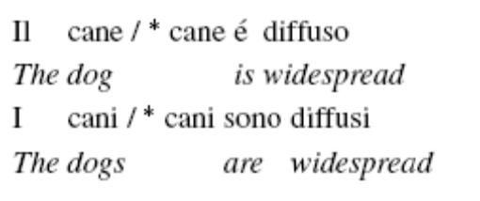
- they can have generic or habitual readings.
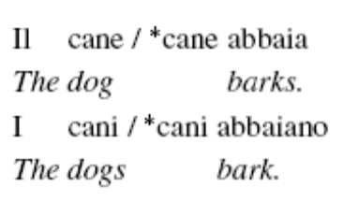
- Vergnaud and Zubizarreta (1992):
The Romance definite determiner, (singular or plural), is ambiguous between a contentful determiner encoding normal definiteness (i.e., ι) and an expletive
NPs (with no Dº) are types
DPs are tokens

Some question about being “well established” kinds, Dayal concludes that its hard to test or compare languages for accommodation across speakers.

- Where English and Romance part company
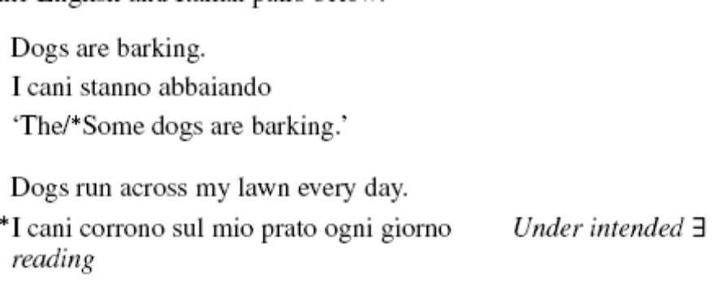

- Krifka et al 1995:
Romance definites can be interpreted in the restrictor of a quantifier but not in its nuclear scope.
The Romance plural definite is a theme maker holding the place of a semantically indefinite NP.
Vergnaud and Zubizaretta (that the determiner is an expletive in kinds) cant explain why the expletive is not available, without blocking DKP in the nuclear scope. I don’t know why.
The Spanish below can only have a contrastive meaning for the verb not Y meaning.
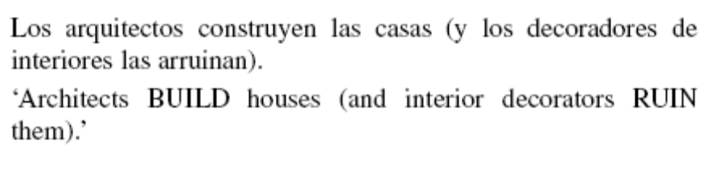
The difference between the bare plural and the definite plural have to be accounted for.

At the very least the definite determiner carries a weak presupposition of existence, which explains why it cant be in the nuclear scope of an X.

4.3. Optional Definiteness in German Kind Terms
- German allows bare plurals and definite plurals, and bare mass and definite mass terms as kinds.
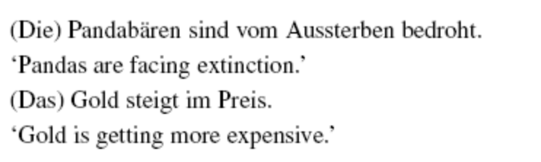
German shows an interaction of the scale of ⍳⋂ and the Blocking principle that if there is a lexical type shifter it must be used over the covert type shift. The canonical meaning is ⍳, so ⋂ can be null.

- The Blocking principle still holds on the canonical form of the determiner (⍳): singular kind terms and familiar/anaphoric terms are higher in definiteness than plural kind terms or mass kind terms
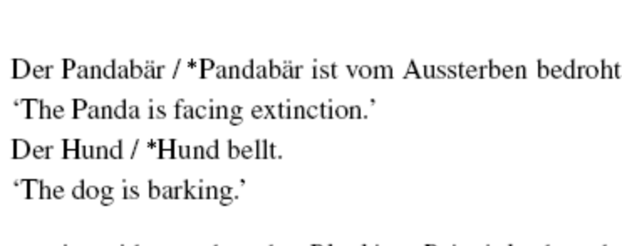

4.4. ‘Optional Definiteness’ in Singular Terms
Is it possible for optional definite marking in singular kinds?

Hungarian, Brazilian Portugues, Hebrew have both bare and defnite singular kinds.

Not the same kind of optionality as german .

Speculative discussion.

- English doesn’t have bare singulars because these operations needed in singular kind formation are all lexicalized in English.
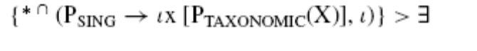

- Hebrew: If a language has a definite determiner but no indefinite determiner then a bare singular would be possible with the ∃s shift
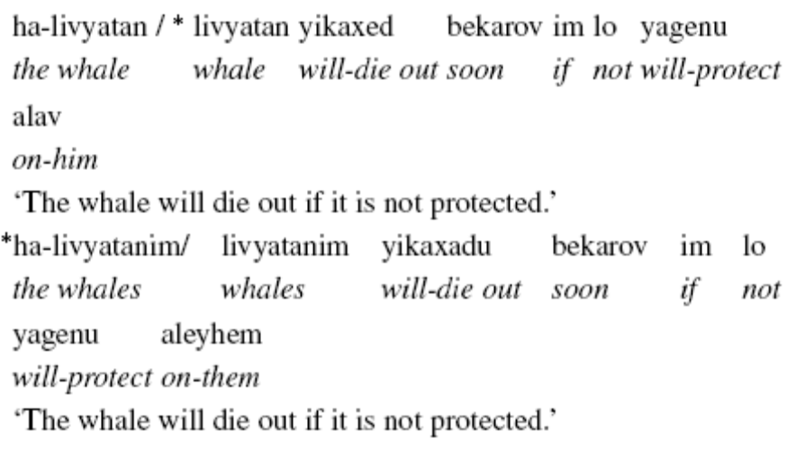

- Doron 2003: found some bare singulars that are kinds, meaning a null ⋂ shift rather than a ∃ shift in subject position of a categorical statement (wtf is a categorical stamement, not a generic statement?.). In other positions the bare singulars could be considered to beincorporated (Van Geenhoven 1998)
Maybe categorical statements for the singular to become mass, and that is how it gets the null ⋂
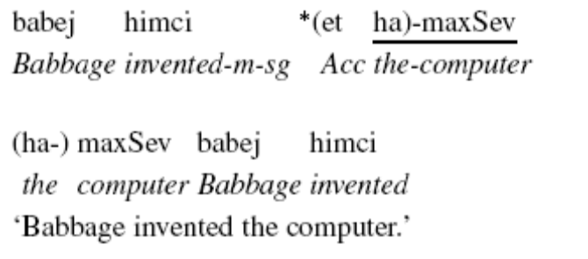

Hebrew is left for future work.

Hungarian has a definite determiner and no indefinite determiner but it doesn’t have bare singulars. (only in incorporated preverbal position Farkas and deSwart 2003).

Brazilian Portuguese has both definite and indefinite determiners but still allows bare singulars.

In a footnote Dayal confirms my suspisison that what her definiteness scale is really a markedness scale and would rely on a functional account like one that can be provided with OT ☺ The idea that she has that some implications are only interesting when one of the crossed factor table doesn’t exist, smacks of a functional OT type of implication system. Rather I think it’s interesting when each cell of the crossed factor matrix is found.

What are Opaque and transparent readings ??!!
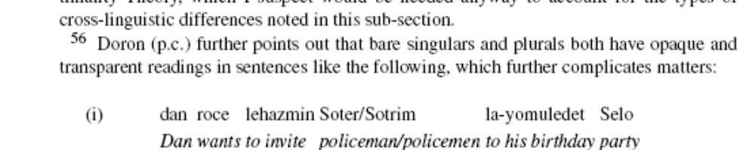

5. Conclusion

Using number morphology as a window into the problem, we have discovered a number of facts that were not previously known. Which are…?

Crosslinguistic generalizations fall out from the theory.

Here are some types of languages that are predicted to be impossible the theory

Languages without determiners: (Hindi in reverse is predicted to not exist)
Bare plurals have more restricted meanings than bare singulars.
Atomic kind formation (when the kind is an atom with no accessible subgroups) is triggered by plural number morphology.
So we should only find atomic kinds on singulars.
And we should find that all plural kinds have subgroups.

Languages with definite determiners: (English in reverse predicted to not exist)
⍳ universally ranks higher than ⋂
Singular morphology forces a singular kind to shift by ⍳ (ie the definite determiner).
So a language can only use the definite determiner on plurals if it used for singulars.

Languages with optional definites: (German in reverse is predicted not to exist)
This language would lexicalize ⍳and ⋂, but would enforce the blocking principle on the lower ranked one.

What’s the relevant data?
Combining number morphology, and mass terms, and collectives.
With definite determiners
With kind (in generic/habitual/property statements, sometimes in episodic statements too though) and object readings (in episodic statements).

So, I’ll write her conclusion for her.
Blocking principle: don’t use null determiners when overt ones are available for that denotation/type shift.

Singular morphology takes away access to subgroups

Definite determiners like “the” are crosslinguistically used with kinds because it denotes ⍳ which is the same as ⋂.
So, kinds have an affinitiy with definites, not with indefinites like people think (other people, Im assuming the people who use the term “generic”?)

Kinds can have the a determiner which is used for novel things, the trouble is that most kinds are known, but if you make a novel one, its fine.

There is a markedness scale of ⍳ and ⋂ which languages would rather code which when building lexical items

So, there should be a functional reason, or OT semantics to get the crosslinguistic generalizations of lexicalization.

Dayal carefully avoids having the kinds in object position, yet she uses them in the subject of unergatives, or identities like the car is blue, property =property would do just as well no? Look for examples where dayal uses kinds in the subject of true transitives? (even if they are generic it should be ok)

Doesn’t the distribution of kinds, being only in generic, or habitual or identity situations make better sense to have it as a property not an entitity?

What makes it an entitity is the ability to refer to the individuals in a later sentence? But we know about the marble example that if you make the marbel contextually saleient enough you can refer to it uniquely evne though it was never introduced. Can an individual of a kind be introdicuced by the shear “dog” property. Why not. The speaker makes the inference that… actually does it happen?

You know, dogs bark.
#?Look at it, its barkng now.
Youcant refer to the indifidual in the kind, how would the abe differt from referring to somthign that instantiates a property rather htan something that denotes all individuals in all worlds with that property.

Her references that I read, would like to read:

Chierchia, G.: 1998, ‘Reference to Kinds Across Languages’, Natural Language Semantics
6, 339–405.
Van Geenhoven, V.: 1998, Semantic Incorporation and Indefinite Descriptions, CSLI.

Would it be ok to refer to this as the “variable based approach” as indefinites are not quantifiers but are variables that get bound by other operators.
The negated ones required paraphrasing to get the narrow reading to be clear, why doesn’t the want operator need this? Or do I just know too little about want and ints semantics. Should it be something like, John wants there to be a world where he meets a movie star? And There is a particular movie star such that there is a world where john wants to meet that particular movie star.
“Following Montague, we will relativize the interpretation function to a possible world and an assignment function. As before, we can drop reference to an assignment when the choice of assignment doesn't matter,” (Heim & Kratzer 1998:304)
“For the representation language I will adopt a language such as TY2 which contains variables over worlds. I assume that expressions are assigned an intensional type ás, añ, but that they are automatically provided with (distinguished) variables over worlds (which are notated as subscripts) which can be abstracted over (see, e.g., Groenendijk and Stokhof (1984) for details). When confusion is unlikely to arise, I will omit marking the world variable explicitly.”
Dayal avoids kinds in object position since an incorporation account is possible. (Dayal 2004:403)
Chiercia says mass are <e>, only count nouns are <<e,t>,t>. Baker says <e> for all NPs. Dayal doesn’t adopt Chierchia’s analysis for mass nouns. She remains neutral on whether bare plurals denonte plurals or their denotation includes singular and plural entities.
Why is there a lambda s in this one but not the others…yet all P have a subscript s on them…
What if “ek” was actually the determiner for novel things, and that’s why you cant have a bare singular to introduce novel stuff, if thats what I’m understanding? Does she mean that bare nominals can be kinds or generics (what is this?) or unique entitites, but they must be familiar and cant be non familiar?
Kratzer analyzies ‘a’ as a choice function or an indefinite, while ‘some’ is only a choice function. Dayal used some here instead of one, assumedly because one is only a choice function too?
Is the need I feel for a contrastive another machine the sign of a narrow scalar implicature?
Dayal says ‘but see Van Geenhoven 1999’
Dayal has a footnote saying that since this is an object, maybe its incorporated. But the same behaivior is found in subject position. BUT the subject she chooses is the identity kind ☹ not a transitive kind. Are there any examples of subjects in this paper that are in transitives?? “parts of this machine are in the next room.” Check with speakers but, in Hindi the adverbial in the next room comes first, and parts comes next to the verb, as it would when it is truly the object.
Dayal says it this way: generic readings of the definite singular cannot be derived simply by quantifying over instances of the kind. That’s the same thing right?
This is fine for me

